WDS111HZ-EPON User Manual

Version：V1.1

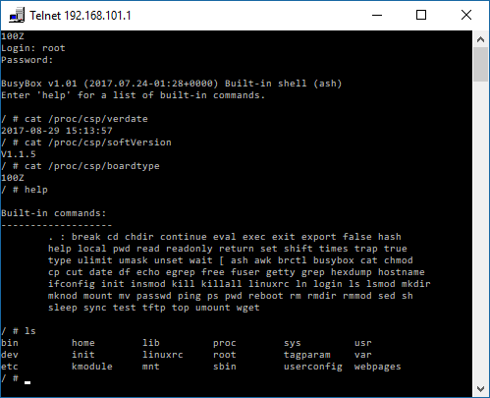

root example

telnet 192.168.101.1
root/root621
cat /proc/csp/verdate
cat /proc/csp/softVersion
cat proc/csp/boardtype

Contents
1 Attention 2
1.1 Install Caution 2
1.2 Precautions For Use 2
2 Introduce 3
2.1 Feature 4
2.2 Environmental Parameter 4
2.3 Interface 5
2.4 Application 5
3 Login ONU web 6
4 Internet service configuration 7
4.1 PPPoE Dial-up access Internet 7
4.2 Static IP access Internet 9
4.3 DHCP access Internet 11
4.4 ONU Bridge mode access Internet 13
5 ONU Management 13
5.1 Login Password 13
5.2 Reboot ONU 14
5.3 Restore Default 14
5.4 Software upgrade 15
5.5 Backup/Restore ONU Configuration 15
6 Other 16
6.1 LOID modify 16
6.2 web remote management 17
7 Conclusion 18

Attention

Install Caution
- Do not near flammable or conductive items, high temperature, direct sunlight or moist environment, or on PC chassis, and check whether other home equipment placed around stability.
- Check the cable line.Test and confirm the ac or dc input voltage in the range of allowable, and direct current (dc) correct polarity.
- Unless the manufacturer has given permission, please use the volume and the types of the power supply with Ming products attached adapter
- To prevent lightning damage to the product, ensure the safety of the power socket and power adapter earthing end grounding.Make sure the equipment in thunderstorm weather of power supply and unplug all link.
- Equipment shall be less than 10% of the input voltage fluctuations, power plug with a refrigerator, hair dryer, electric iron not use the same socket.
- To avoid any damage to body by power socket overload, or damage to cause electric shock or fire plug, please check the power cord, if found damaged, please change immediately.
- Please place the equipment on the smooth plane and equipment cannot be placed on other items.
- Equipment work is easy to generate heat, should maintain proper cooling space in order to avoid product damage caused by overheating.Slender hole on the shell for thermal design, please keep the ventilation clean, avoid the items from the radiator into device, otherwise may cause short-circuit equipment damage or fire.Don't put the liquid on the surface of equipment.

Precautions For Use
- Please read carefully before using equipment user manual, and follow the user manual and all the matters needing attention on the product.
- Avoid eyes optical interface, in order to avoid interface laser radiation injury of eyes. Please wear safety glasses, in order to effectively protect your eyes from damage. Optical interface. when not in use the best sheath with optical fiber interface.
- Please shut off the equipment power When not in use.
- Please make sure the power switch is closed before plug the power supply, to avoid surge. Please be careful when remove the power supply, transformer temperature may be higher.
- For safety, please do not open the shell of equipment, especially in equipment electric.
- Unplug the power supply before cleaning equipment. Use a soft dry cloth cleaning equipment, do not use the liquid or spray.
Do not use this product connected to any electronic products unless got our engineer allow. because any wrong connection may cause electricity or fire danger.

Introduce
FD111HZ EPON ONT is one of the EPON optical network unit design to meet the requirement of the broadband access network. It apply in FTTH/FTTO to provide the data and video service based on the EPON network.
EPON is the latest generations of access network technology. IEEE802.3ah is the standard protocol of EPON. The EPON standard differs from other PON standards in that it achieves higher bandwidth and higher efficiency using larger, variable-length packets. EPON offers efficient packaging of user traffic, with frame segmentation allowing higher quality of service (QOS) for delay-sensitive voice and video communications traffic. EPON networks provides the reliability and performance expected for business services and provides an attractive way to deliver residential services. EPON enables Fiber To The Home (FTTH) deployments economically resulting to accelerated growth worldwide.
FD111HZ is based on ZTE high-performance xPON access chip. The chip supposes three mode：EPON/EPON/P2P, comply with the EPON standard of g.984, g.983, 802.3-2005, CTC EPON equipment technical requirements, have good xPON interoperability compatibility
FD111HZ provide one GE auto-adapting Ethernet ports. The FD111HZ features high-performance forwarding capabilities to ensure excellent experience with Internet and HD video services. Therefore, the FD111HZ provides a perfect terminal solution and future-oriented service supporting capabilities for FTTH deployment. It has good third-party compatibility to work with the third party OLT, such as Huawei/ZTE/Fiberhome/Alcatel-Lucen.

Feature
- Full compatible with IEEE802.3ah
- Support port-based rate limitation and bandwidth control
- In compliant with IEEE802.3ah Standard
- Up to 20KM transmission Distance
- Support data encryption, group broadcasting, port Vlan separation , etc.
- Support Dynamic Bandwidth Allocation (DBA)
- Support ONU auto-discovery/Link detection/remote upgrade of software;
- Support VLAN division and user separation to avoid broadcast storm;
- Support power-off alarm function ,easy for link problem detection
- Support broadcasting storm resistance function
- Support port isolation between different ports
- Support three layer routing functions
- Support ACL and SNMP to configure data packet filter flexibly
- Specialized design for system breakdown prevention to maintain stable system
- Support software online upgrading
- EMS network management based on SNMP ,convenient for maintenance

Environmental Parameter
- Environmental Requirement
Operation temperature：-0°C～50°C
Operation humidity：5%—95%
- Power Specification
Rate voltage/ current：12 V/0.5A
Power：<2W

Interface
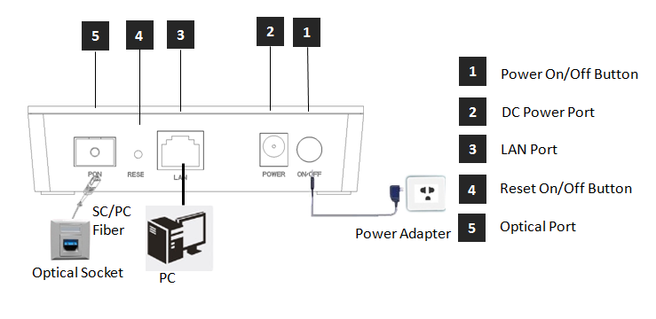
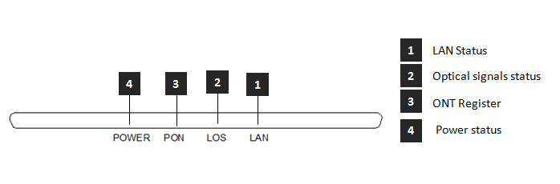
Indicator light |  |  | Introduction
1 | LAN | LAN port status | On: Ethernet connection is normal;  Blinking: Data is being transmitted through the Ethernet port;  Off: Ethernet connection is not set up;
2 | LOS | EPON optical signals | On: Optical power lower than receiver
3 | PON | ONT Register | On: Success to register to OLT;  Blinking: In process of registering to OLT;  Off: In process of registering to OLT;
4 | PWR | Power status | On: The ONT is power on;  Off: The ONT is Power off;

Application
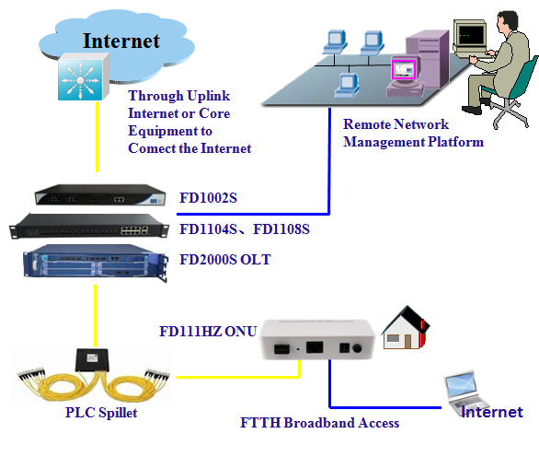

Login ONU web
Set computer local IP address manually to 192.168.101.100, using network cable, connect the computer with EPON ONU Ethernet ports, open a browser, copy and paste the URL: http://192.168.101.1
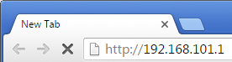
Page as shown below:
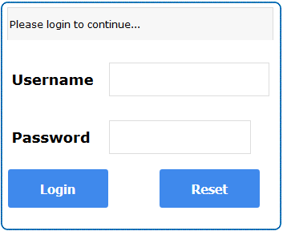

Input Username: adminisp Password: adminisp
Click “Login” button. Web interface of basic information as shown below:
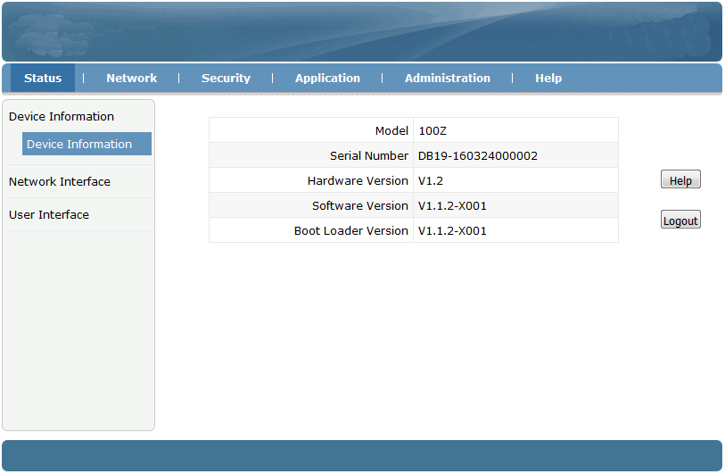

Internet service configuration

PPPoE Dial-up access Internet
①Click Network ->WAN->WAN Connection, Login to the web interface as shown below:
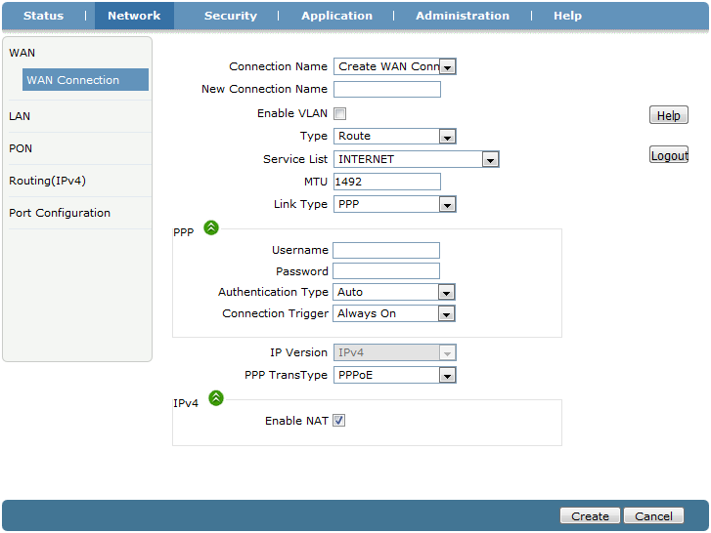
②Connection Name choose “Create WAN Connection”, give the WAN a name(ex:internet), check “Enable VLAN”, set correct VLAN ID and 802.1P, Type is “Route”, Service List to “INTERNET”, Link Type set to “PPP”. Fill in PPPoE username and password. Other configuration keep in default. Click “Create” button.
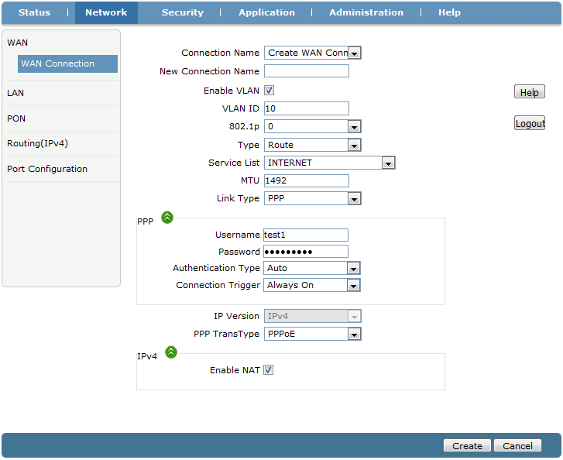
③Click Network -> LAN->DHCP Server, Check ”Enable DHCP Server”, Click “Submit” button to enable the DHCP function.
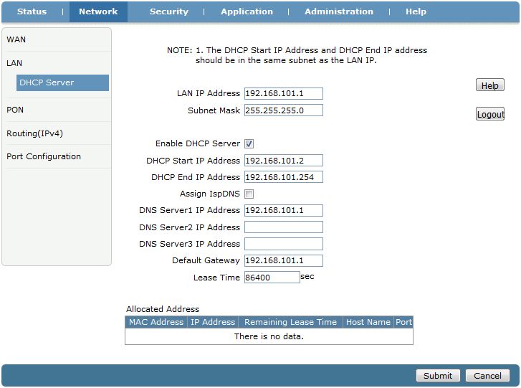
④Click Status->Network Interface->WAN Connection, can check the PPPoE WAN is connected or not. If the WAN get an ip address, DNS address and the Ipv4 Connection Status is Connected, mean the PPPoE dial-up is successfully. PC connect to ONU LAN port can surf the Internet.
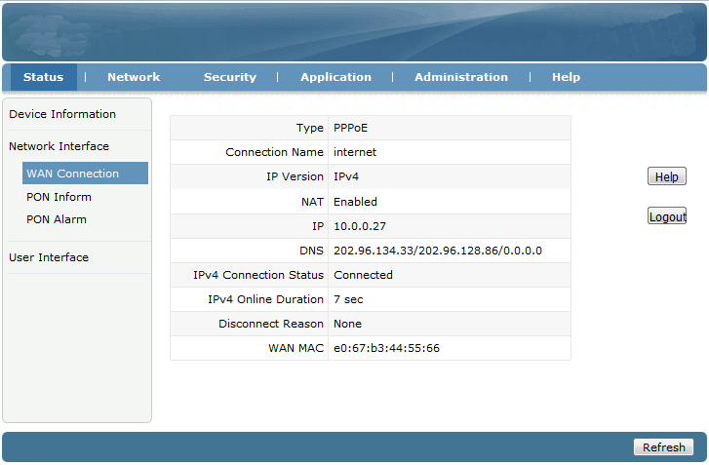
ONU on the premise that registed and online, but IP and DNS without address, the IPv4 Connectioin Status show Disconnected.and the Disconnect Reason is “AUTHENTICATION FAILURE”, Please check the PPPoE username and password. If IPv4 Connection Status is “connecting” all the time, Please check the OLT configuration.

Static IP access Internet
①Click Network->WAN->WAN Connection

②Connection Name choose “Create WAN Connection”, give the WAN a name(ex:internet2), check “Enable VLAN”, set correct VLAN ID and 802.1P, Type is “Route”, Service List to “INTERNET”, Link Type set to “IP”. IP type set to “Static”. Fill in IP Address, Subnet Mask, Gateway, DNS server ip address. Other configuration keep in default. Click “Create” button.
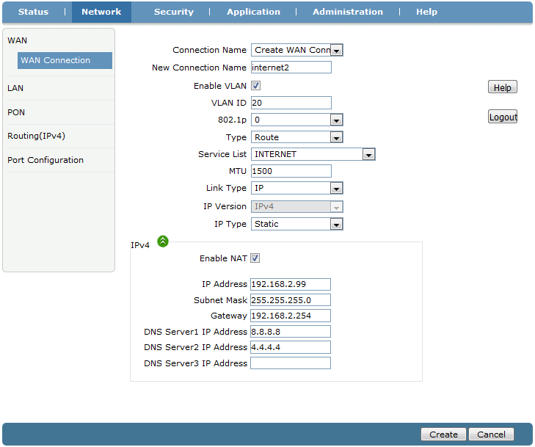

③Click Network -> LAN->DHCP Server, Check ”Enable DHCPServer”, Click “Submit” button to enable the DHCP function.

④Click Status->Network Interface->WAN Connection, can check the IP WAN is connected or not. If the WAN get an ip address, DNS address and the Ipv4 Connection Status is Connected, mean the IP WAN is connected. PC connect to ONU LAN port and obtain an IP address automatically can surf the Internet.
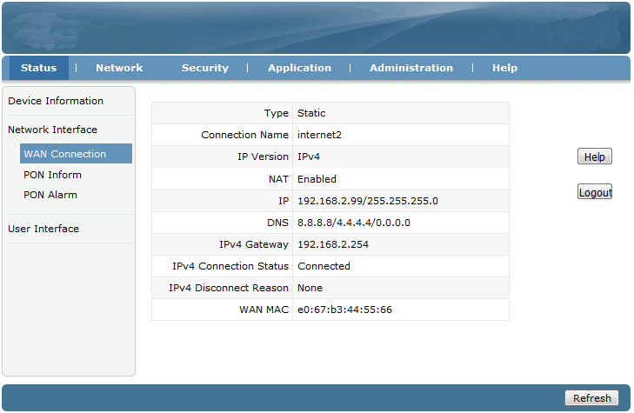

DHCP access Internet
①Click Network->WAN->WAN Connection.

②Connection Name choose “Create WAN Connection”, give the WAN a name(ex:internet3), check “Enable VLAN”, set correct VLAN ID and 802.1P, Type is “Route”, Service List to “INTERNET”, Link Type set to “IP”. IP type set to “DHCP”. Other configuration keep in default. Click “Create” button.
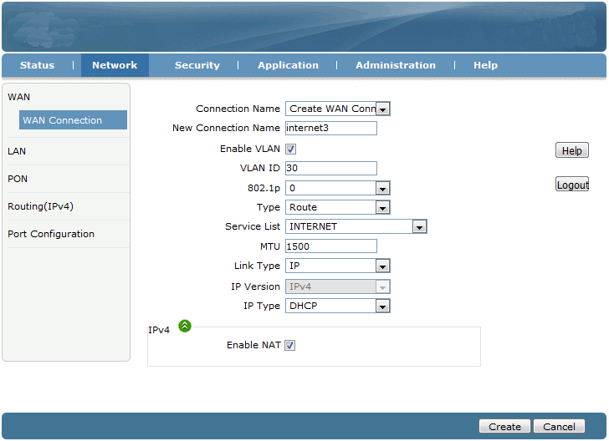

③Click Network -> LAN->DHCP Server, Check ”Enable DHCPServer”, Click “Submit” button to enable the DHCP function.

④Click Status->Network Interface->WAN Connection, can check the IP WAN is connected or not. If the WAN get an ip address, DNS address and the Ipv4 Connection Status is Connected, mean the IP WAN is connected. PC connect to ONU LAN port and obtain an IP address automatically can surf the Internet.
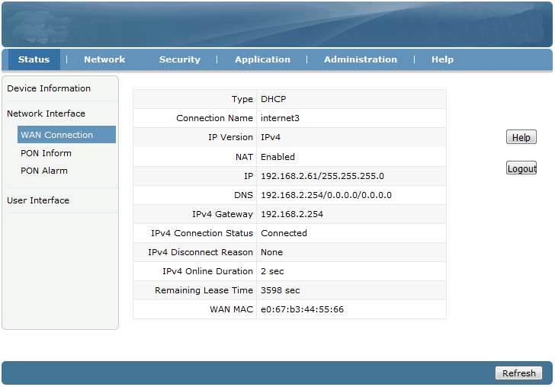

ONU Bridge mode access Internet
ONU work in Bridge mode in factory default. In Bridge mode, ONU no need do anything in web interface. ONU just need to set correct port vlan(ex:access, trunk) in OLT.
Note:If ONU have set to Route mode to access Internet before. Please disable LAN port DHCP function when you change the mode to Bridge.

ONU Management

Login Password
Click Administration->User Management, can change Administrator password and normal user’s username and password.
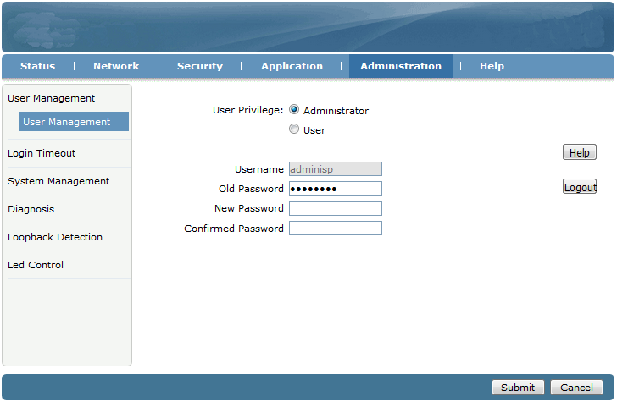

Reboot ONU
Click Administration->System Management->System Management, Click “Reboot” button can reboot the device.
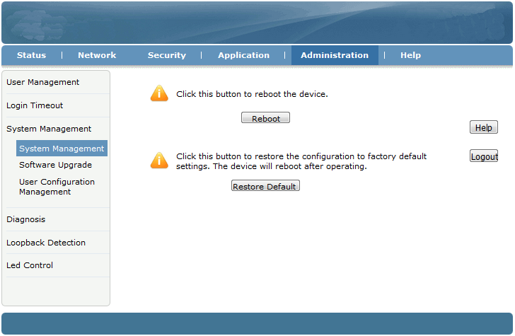

Restore Default
Click Administration->System Management->System Management, Click “Restore Default” button to set ONU to factory default.
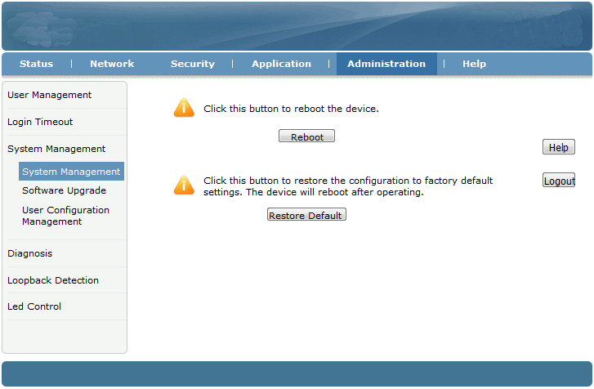

Software upgrade
Click Administration->System Management->Software Upgrade to upgrade the ONU firmware version.
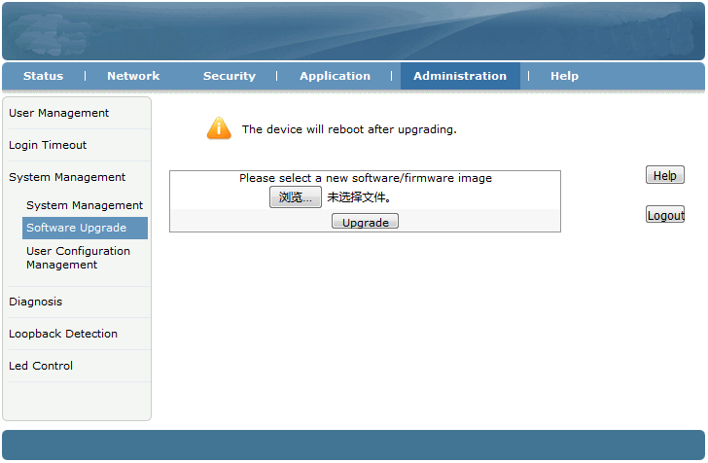

Backup/Restore ONU Configuration
Click Administration->System Management->User Configuration Management, Click “Backup Configuration” to export configuration, Click “Restore Configuration” to import configuration.
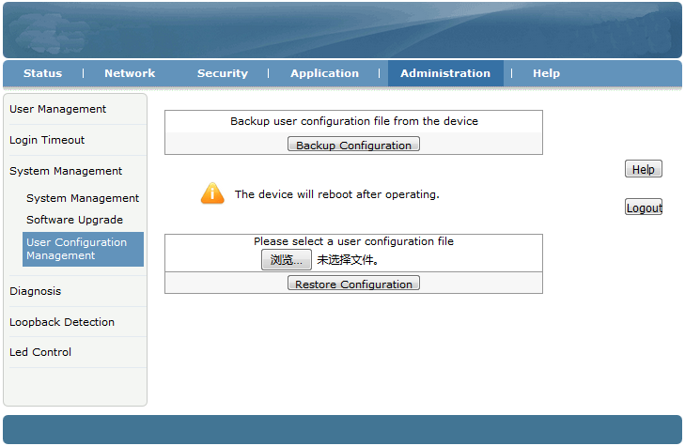

Other

LOID modify
LOID use to register. In default LOID the same as ONU MAC address. Click Network->PON->LOID can view and modify LOID.
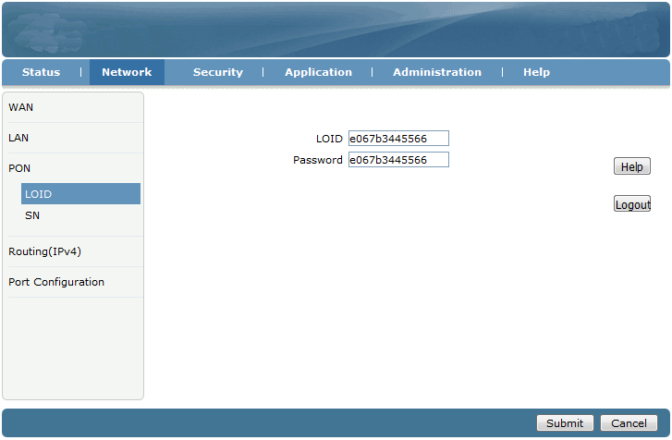

web remote management
On the premise that OLT have configured ONU management ip. Click Security->Service Control->Service Control, check “Enable”, Ingress select “OAM_WAN_MNGIP”, set “Start Source IP Address” and “End Source IP Address”, Mode set to “Permit”, check “HTTP”. Click “Add” button finally.
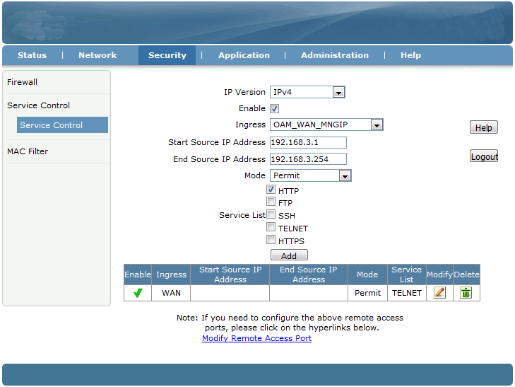

One more item in service list as shown below:
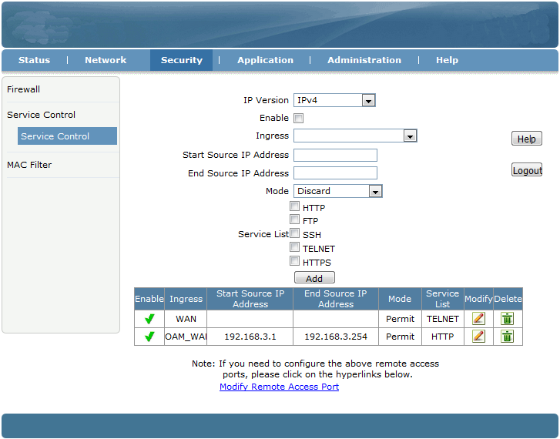

Conclusion

Thanks for using Wodaplug Products !

Contact：EU worldwide distribution:
Tomorrow systems s.r.o.
Karlstejnska 323
252 25 Orech – Prague west
Czech Republic

GSM: +420 608 262 004 , +420 775 262 900
Tel. : +420 257 211 010 (store, service)
Email: info@wodaplug.com
Website：www.Wodaplug.com
www.524wifi.com / www.compexshop.com

